1. Mockup
   * Main Page  
     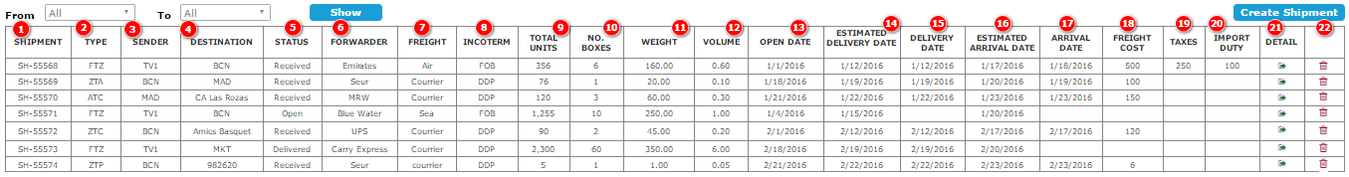
     + From list: All, Factory, Zone, Agent, Customer
     + To list: All, Factory, Zone, Agent, Customer
     + Column explanation

|  |  |  |
| --- | --- | --- |
| **Column** | **Meaning** | **Calculation** |
| (1) | Shipment’s Id |  |
| (2) | Shipment type (FTZ, FTA ….) |  |
| (3) | Sender’s code |  |
| (4) | Destination code + description |  |
| (5) | Status | * If (15) = empty   + Status = “**OPEN**” * If (15) <> empty and (17) = empty   + Status = “**TRANSIT**” * If (15) <> empty and (17) <> empty   + Status = “**RECEIVED**” |

1. Business
   * Filtering options:

|  |  |  |  |  |  |
| --- | --- | --- | --- | --- | --- |
| To  From | **All** | **Factory** | **Zone** | **Agent** | **Customer** |
| **All** | (1) | (2) | (3) | (4) | (5) |
| **Factory** | (6) | (7) | (8) | (9) | (10) |
| **Zone** | (11) | (12) | (13) | (14) | (15) |
| **Agent** | (16) | (17) | (18) | (19) | (20) |
| **Customer** | (21) | (22) | (23) | (24) | (25) |

* + Factory View

|  |  |
| --- | --- |
| (1) | Show all shipments of Factory and his downlines |
| (2) | Show shipments from all downlines to Factory |
| (3) | Show shipments from all to Zones under Factory |
| (4) | Show shipments from all to Agents under Factory |
| (5) | Show shipments from all to Customer under Factory |
| (6) | Show shipments from factory to all downlines |
| (7) |  |
| (9) |  |
| (10) |  |
| (11) |  |
| (12) |  |
| (13) |  |
| (14) |  |
| (15) |  |
| (16) |  |
| (17) |  |
| (18) |  |
| (19) |  |
| (20) |  |
| (21) |  |
| (22) |  |
| (23) |  |
| (24) |  |
| (25) |  |

* + Zone View
  + Agent View
  + Customer View
  + Test